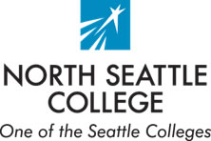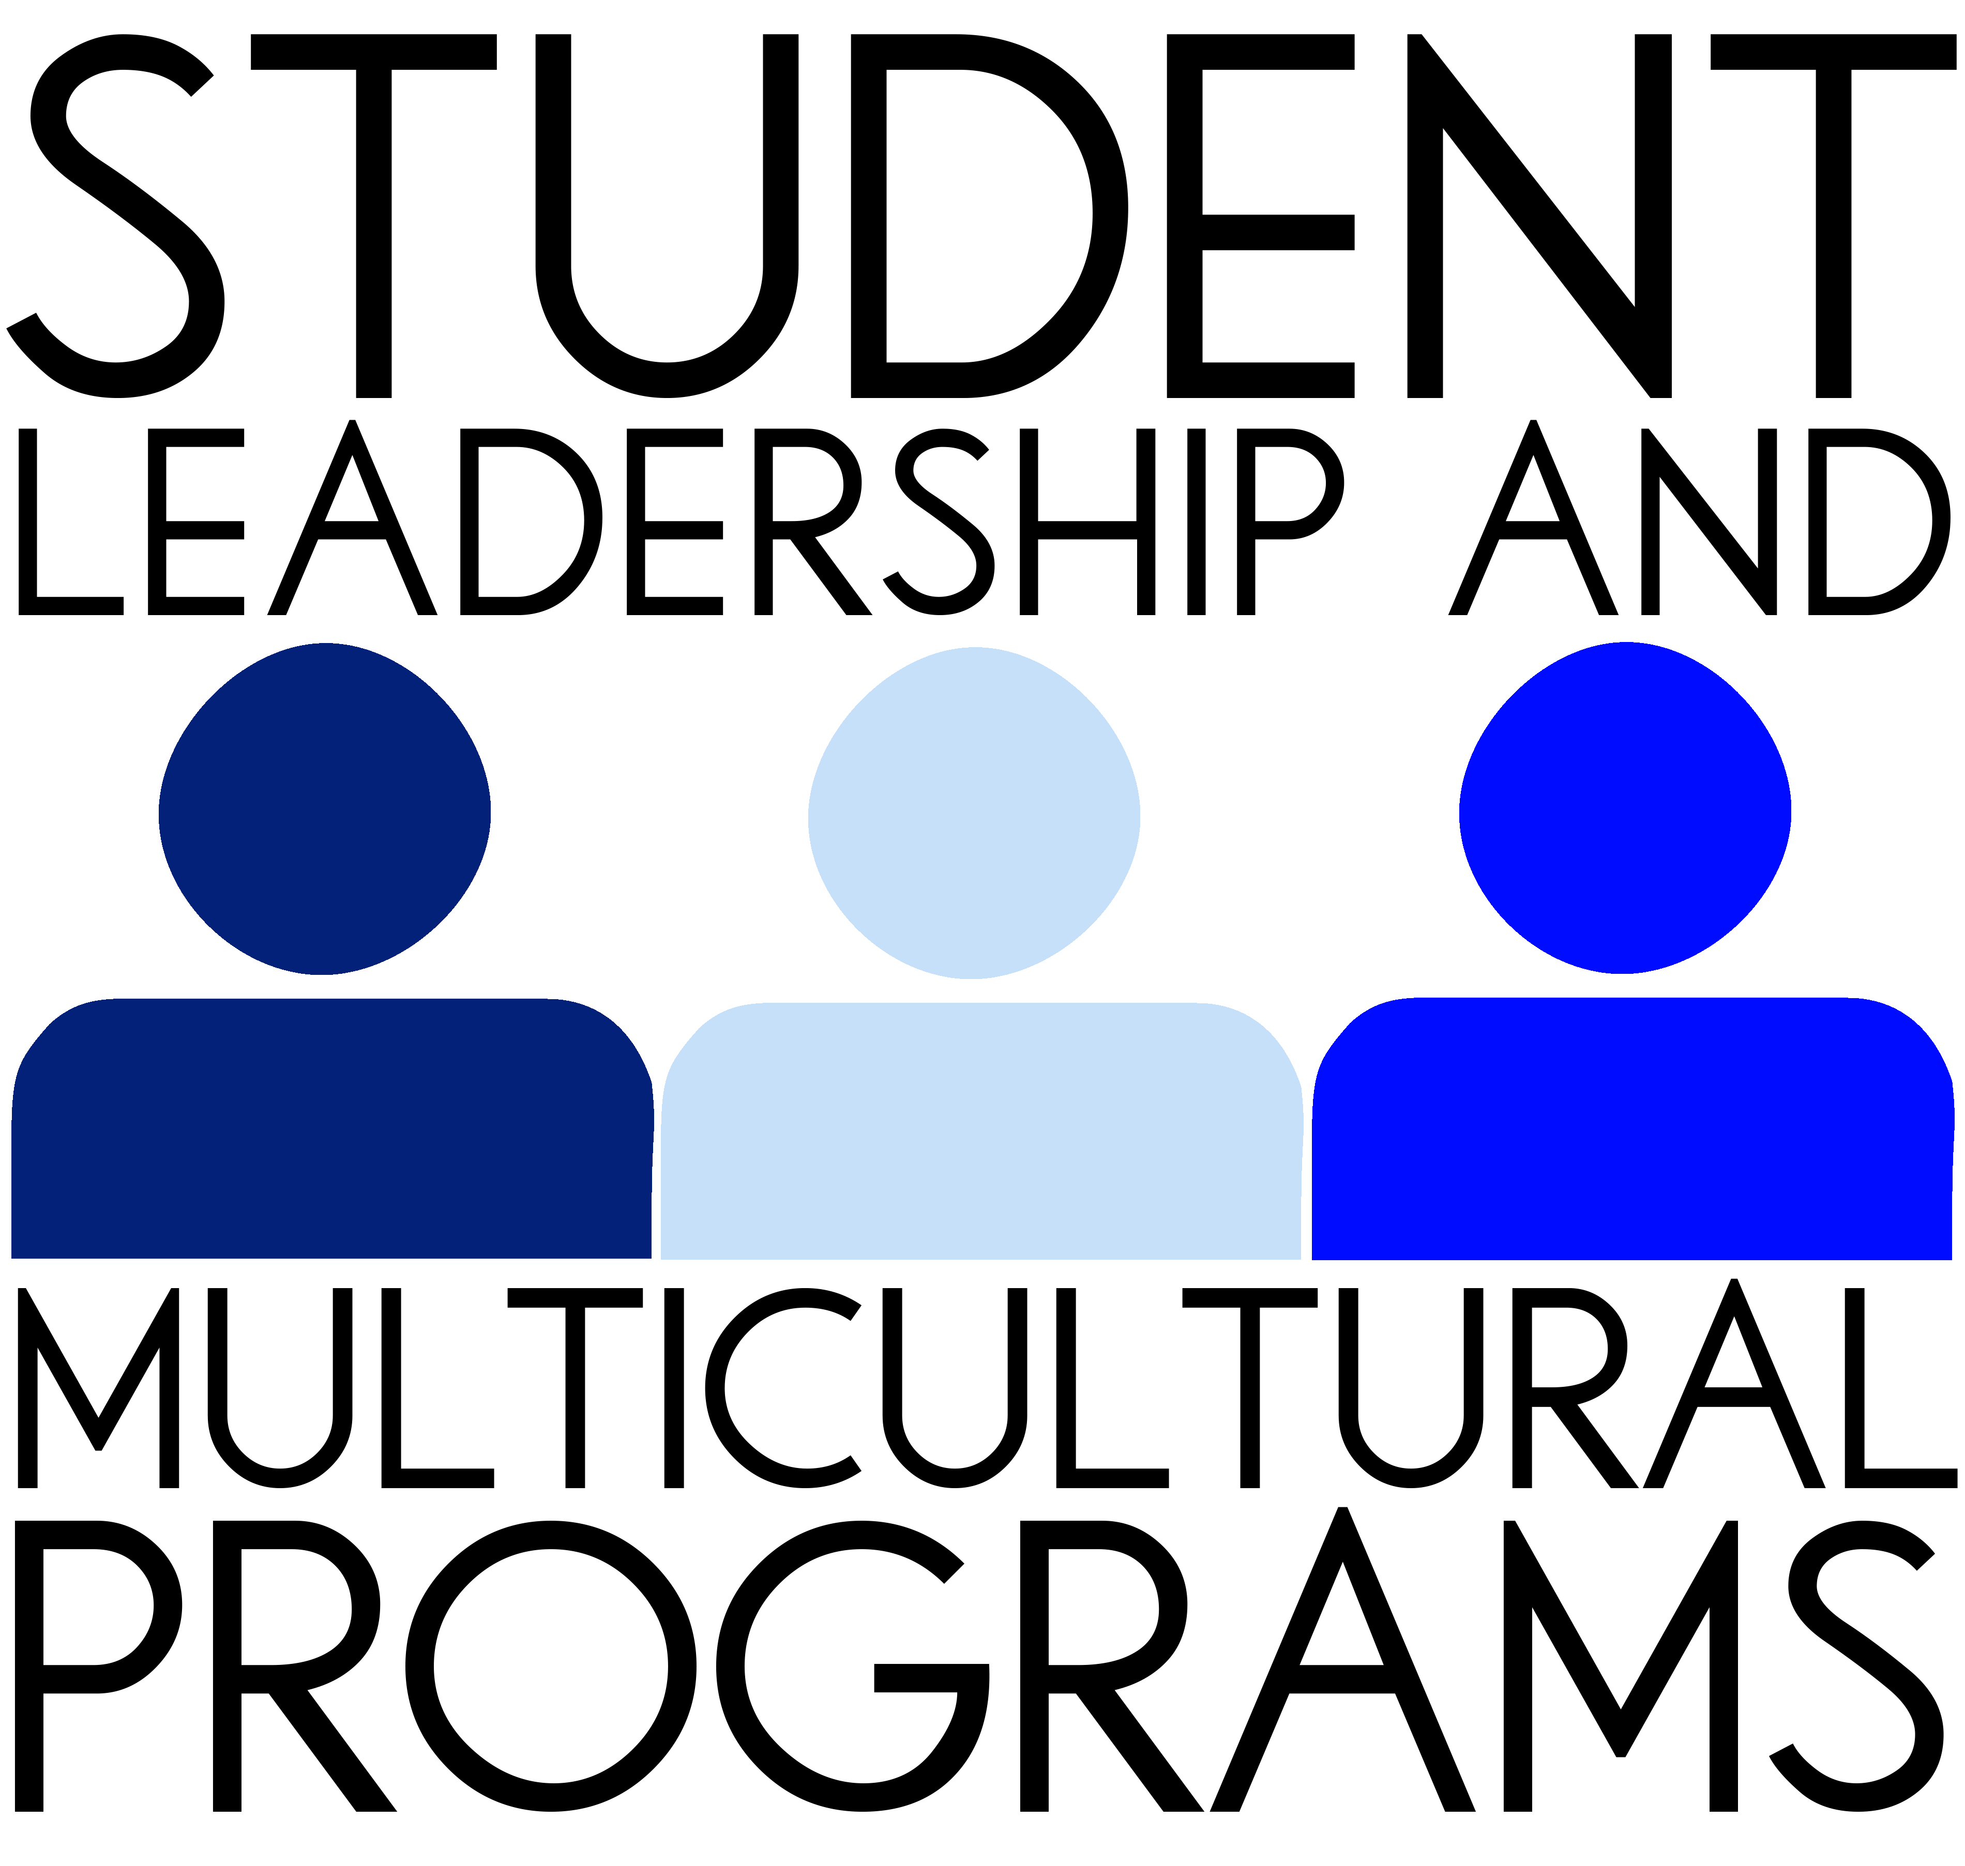

25th Annual
Students of Color Conference

“Moments to Movements” #25yearsofpeoplepower

Yakima, WA
Thurs - Sat, April 23-25, 2015

APPLICATION PACKET
For students attending North Seattle College

Produced by the Washington State

Multicultural Student Services Directors’ Council

APPLICATION REMINDERS:

- Application due date: March 5 for CC1446 (Student Leadership and Multicultural Programs)

- Notified whether you have been accepted to attend the SoCC: March 10

- Conference dates: Thursday, April 23 through Saturday, April 25. You will need to make arrangements with your instructors to be absent from class April 23 and 24.

- Pre Conference Orientation: Thursday, March 12, 1-2:30 or 3-4:30, club room CC1360 (mandatory)

- Post-Conference meeting on Thursday, April 30, 1-2:30 or 3-4:30 in the Club room CC1360 (mandatory)

- Questions / contact: Jeffrey.vasquez@seattlecolleges.edu

Scholarships sponsored by:
North Seattle College Department of Student Leadership & Multicultural Programs
February 3, 2015

Dear Student,

Student Leadership and Multicultural Programs would like to invite you to attend the 25th Annual Students of Color Conference, “Moments to Movements” #25yearsofpeoplepower. The conference will be held in Yakima, WA from Thursday-Saturday April 23-25, 2015. This annual conference is organized by the Washington State Multicultural Student Services Directors’ Council which is a group of professionals who advocate for diversity, equity and student success for each of our campuses. This year we expect about 700 student participants from colleges throughout the state.

All students who will be enrolled spring quarter are invited to attend. Both students of color and white students come back to campus sharing stories about how meaningful, and in some cases life changing, this conference was for them. White students often explain this as an “eye-opening experience” since at the conference, white students are the minority among hundreds of students of color. By the end of the conference, students leave feeling challenged, yet also committed to working toward creating a more fair, just and equitable society.

The conference begins by exploring identity: What does it mean to be a person of color in predominately white society? White students also learn that they too have a culture and a unique role in working for social justice. The conference will provide rich learning opportunities through workshops, keynote speakers and meeting and talking with people who are both like you and different. Following are quotes North students have said about the conference:

“The guest speakers were amazing; they awakened my spirit to fight for a better tomorrow”
“I enjoyed meeting new people from different diverse backgrounds”
“The performances at the open mic put a smile into my heart”
“The conference encouraged me to work hard and aim high.”
“It made me realize that I can achieve my goals and that there are already individuals like me that have achieved their potential.”
“Very fun and educational, the people are just beautiful!”
“It was a mind blowing experience. It really changed my ideas about race and minority issues”
“I thought I knew African American culture but after attending the African American session I came to realize how diverse we are.”
“I loved meeting people, the speakers, interacting with all the different people, I hope to go again.”
“I have a better understanding of diversity.”
“The seminars were very informative - I wish I could have gone to more of them.”

All registration costs, accommodations, and transportation will be covered by the Department of Student Leadership and Multicultural Programs for those students selected to attend. A copy of your spring quarter class schedule must be submitted with the application. Submit your application to the Student Leadership & Multicultural Programs office CC1446 by no later than Thursday, March 5.

Participants will be required to attend a mandatory orientation meeting on Thursday, March 12, 1-2:30pm or 3-4:30pm, Club room (CC1360).

Sincerely,

Jeffrey Vasquez, Director, Dept. of Student Leadership & Multicultural Programs
Jeffrey.Vasquez@seattlecolleges.edu (206) 527-3643

AGENDA AT A GLANCE
STUDENTS OF COLOR CONFERENCE - 2015
April 23rd-25th, 2015
Yakima, Washington
“Moments to Movements” #25yearsofpeoplepower

Thursday, April 23rd, 2015
12:00 – 2:00 p.m. Check-in
2:00 – 3:00 p.m. Welcome/Conference Opening/Rhonda Coats Award/Yakima Blessing/Roll Call
3:00 – 4:00 p.m. OPENING KEYNOTE:
4:15 – 5:15 p.m. Advisor/Chaperone Meeting
Identity Groups for LGBTQ students
Identity Groups for Islamic students
Identity Groups for Students with Disabilities
5:30 – 6:00 p.m. Individual School Meetings
6:00 – 7:00 p.m. Light Buffet Dinner w/ Entertainment
7:15 - 9:15 p.m. Concurrent Session 1 – Racial/Ethnic Identity Groups
9:30 – 11:30 p.m. Open Mic sponsored by Spokane CC

Friday, April 24th, 2015
8:00 – 9:00 a.m. Full Breakfast/Announcements
9:00 – 10:30 a.m. Concurrent Session 2 – 101 Workshops
10:30 – 10:45a.m. Transition Time
10:45 –11:45 am MORNING KEYNOTE
11:45-12:00 pm Transition time
12:00-1:30 pm Concurrent Session 3 – Skill Development
1:30 – 2:30 p.m. LUNCH
2:30 – 4:00 p.m. Concurrent Session 4 – Social Justice/Social Activism
4:00-4:15 pm Transition time
4:15 – 4:45 p.m. Individual School Meetings
4:45 – 6:30p.m. Student Networking
6:30 – 7:30 p.m. Dinner
7:30 – 8:30 p.m. EVENING KEYNOTE:
8:30 – 10:00 p.m. Film Presentation:
10:00 – 1:00 a.m. Social Event

Saturday, April 25th, 2015
8:00 – 9:00 a.m. Full Breakfast/Announcements
9:00 – 10:30 a.m. Concurrent Session 5 – Personal Development
10:45 – 11:45 a.m. Student Reflection
11:45 - 12:30 p.m. Closing activities

25th Annual Students of Color Conference – APPLICATION FORM
“Moments to Movements” #25yearsofpeoplepower
April 23-25, 2015
Yakima, WA
DEADLINE for SUBMISSION: Thursday, March 5, 2015
If you have any questions feel free to ask anyone in the Student Leadership & Multicultural Programs office CC1446.

Please write clearly. Incomplete applications will NOT be processed. Selection will be based on the thoroughness and quality of your answers.

Name: _______________________________________________ GPA: __________________

Address: _____________________________________________________________________

Cell #: ____________________________ Home #:____________________________________

Email Address: _____________________________________ SID#: _____________________

On a separate sheet of paper, please type your response to the following questions:

- How do you see the Students of Color Conference benefiting you academically, personally, and professionally?

- Why are you interested in attending the Students of Color Conference?

- Please share a personal experience around a multicultural issue that impacted you.

How many quarters have you attended North? _______ Will you return Fall 2015? __________

Dietary needs, check only if applicable: Vegetarian__ Vegan__ (K)osher or (H)alal___

If applicable, please list any special accommodations needed ____________________________________

Tee shirt size: Small__ Medium__ Large__ XL__ 2XL__ 3XL__ 4XL__ 5XL__

In order to plan well, and thus make the conference experience relevant to the diverse individuals attending, we ask you to answer the following questions:

Age_____ How do you gender identify: Female_____ Male_____ Other _____

How do you ethnically/racially identify: _______________________________________________________

To complete your application please attach the following:
- This Application Form and the answers to the questions listed above
- NSC Student Event Participation Contract
- Emergency Contact Information
- Participation Commitment Letter
- A copy of your spring quarter class schedule

Submit your completed application to Jeffrey Vasquez in the Office of Student Leadership and Multicultural Programs CC1446D by Thursday, March 5. Applicants will be notified of their acceptance by Tuesday, March 10, 2015. If you have not received notice then contact us immediately to confirm that your application was received.
Student Event Participation Contract
Name: _________________________________________ Student ID#_______________________
Email: _________________________________________.. Phone:__________________________

I, the undersigned, am aware of and assume responsibility for my actions in participating in the following activity:
Students of Color Conference
Departing: 4/23/15 at approximately 10:30 am Returning: 4/25/15 at approximately 4:00 pm
TRAVEL RULES – ACKNOWLEDGMENT OF STUDENT CONDUCT
Students traveling as part of a North Seattle College activity are seen as representatives of the college and their conduct during the course of travel is of utmost importance. The student therefore agrees to conform to the North Seattle College Code of Student Conduct and to all applicable rules, regulations and policies of North Seattle College and the State of Washington. The student further agrees to regular attendance at all scheduled events for which the travel/conference/event entails and to the following terms:
- No alcohol or drugs allowed per Code of Student Conduct. Violators may be sent home immediately, at their own expense.
- Students should always travel with another student during free time. Students are not allowed to go on any excursions alone.
- Any damage done to hotel rooms or other property shall be paid for by the responsible students.
- Attendance at all planned group activities and events associated with this travel activity is required.
- Travel to and from the conference/event/activity with the College travel group may be required. Students are not allowed to extend their stay and/or travel separately from the group, unless prior permission has been granted.
I understand that this activity is voluntary and that I have chosen to participate of my own free will. I have been given and have read the Student Code of Conduct and Misconduct Policies. I accept all responsibilities and understand that behavior inconsistent with this agreement will result in disciplinary action to include reimbursement to North Seattle College for all fees and associated travel, lodging and meal costs (this includes the cost(s) for any arrangements made by the College which the College is unable to recover the cost of as a result of your cancellation).

Student Signature |  | Date
Program Advisor Signature |  | Date
Parent/Guardian Name  (Required if student is under 18) | Parent/Guardian Signature | Date

Emergency Contact Information

25th Annual Student of Color Conference 2015

Name of Student
Name of Emergency Contact
Relation of Emergency Contact to Student

Cell #
Home #
Address

Email
Anything else we should know (medical condition, food allergies, etc.)

25th Annual Students of Color Conference – April 23-25, 2015

Commitment Letter

- I am enrolled for at least 10 credits at North Seattle College, and have a GPA of 2.0 or higher.

- I will attend all required conference activities and events. I am willing and will follow the rules and regulations of the conference or meeting that I am attending.

- If for some unavoidable reason, my plans change and I find it is impossible for me to attend; I will inform Student Leadership & Multicultural Programs Office no later than 48 hours in advance.

- If I cannot attend and do not inform the Student Leadership & Multicultural Programs within 48 hours notice, I understand that I am responsible for any costs (~ $350 per student).

- If I am staying in a room paid by North Seattle College, I will not charge anything to it. If charges are accidentally made, I am liable for all additional charges such as food, movies, phone etc.

- I understand that I am representing North Seattle College and will conduct myself in a responsible manner.

- I will attend the SoCC Orientation on Thursday, March 12 at 1-2:30pm or 3-4:30, Club room (CC1360). CIRCLE THE TIME YOU WILL BE ATTENDING.

- I will complete an evaluation and/or write a short response/reflection paper (no more than one typed page) and attend the SOCC Post-Conference Evaluation on Thursday, April 30 at 1-2:30pm or 3-4:30 in the Club room CC1360.

By signing this letter I am committing to the above statements.

Name: _______________________________________ Date: ____________

All students attending this conference must read and sign this letter.

